Stage 7 – Do You Practice Standing Reloads?
COURSE DESIGNER: Tim Herron / Ike Starnes
SCORING: Comstock 11 rounds.
TARGETS: 2 cardboard targets, 5 steel targets
SCORED HITS: 3 Best hits per carboard will be scored.
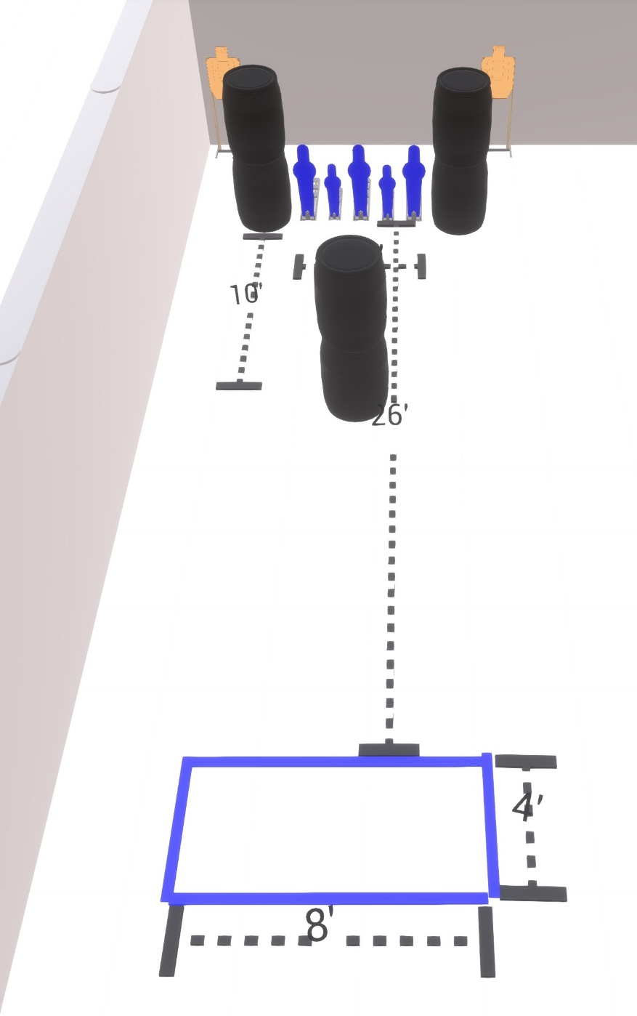

Written Stage Briefing:

Stage 7 – Do You Practice Standing Reloads? - is an 11 round, 55 point, Comstock Course. There are 2 cardboard targets and 5 steel targets. The best 3 hits per cardboard will be scored.

Starting anywhere inside the shooting area.

Handgun is loaded and holstered, wrists below belt.
PCC is loaded held in both hands, stock on belt.

On the audible start signal, engage either the paper targets or the steel targets, then make a mandatory reload and engage the remaining targets.

USPSA / NROI Range Commands:
- Make Ready
- Are you ready?
- Standby
- If finished, unload and show clear
- If clear, hammer down and holster (Handgun)
If clear, hammer down and flag (PCC)
If clear, cylinder closed and holster (Revolver)
- Range is clear

Setup Notes:
2 Target stands / 4 target sticks
3 Large Popper + bases
2 Small Popper + bases
6+ Barrels
